EXAMPLE PROGRAM DESIGN

TRY STEPS 1 & 2 OF THE SOFTWARE LIFE CYCLE for this problem:
Given a person's running speed and distance needed to cover, determine how many minutes into the run to turn around to complete the distance in a round trip.
Step 1: Analyze the problem
Output: midPointMinutes
Input: minsPerMile
miles

Step 2: Design the program
Hierarchy Chart: (see p. 20 of the textbook)
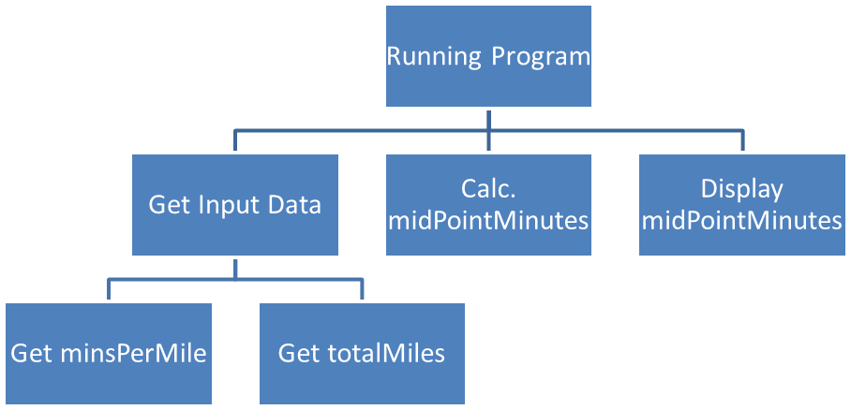

Pseudocode:
Ask the user for running pace (minutes per mile)
Read minsPerMile
Ask the user for total distance to run (in miles)
Read totalMiles
Assign to midPointMinutes, totalMiles/2*minsPerMile
Display midPointMinutes (to 1 decimal place), with a label
End

